How to submit a paper

- First, to submit a paper, it is required to be registered. To do so, go on “Login”.

- Second, click on “create an account” or login if you already have one.

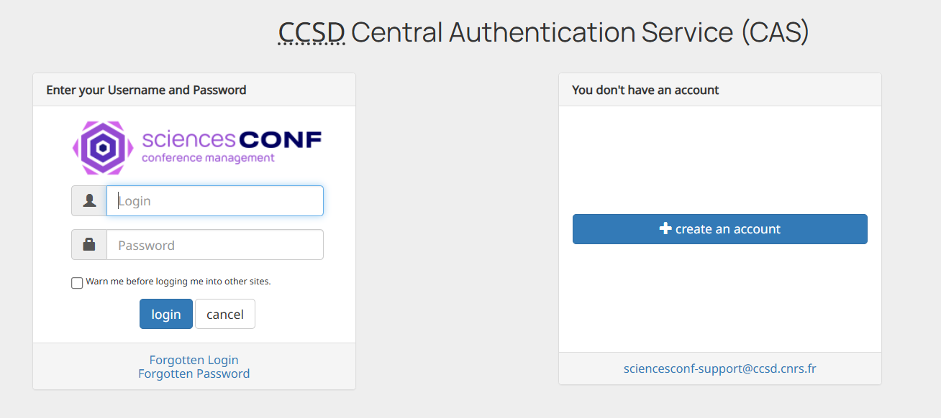

- Third, fill out the form below and generate your account.

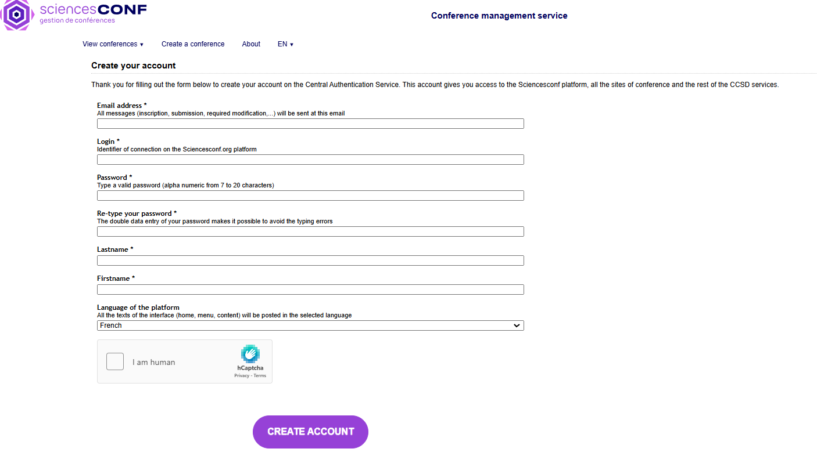
- Fourth, once generated your account you can login. So, go on Login as step one and insert login and password as step two.

- Fifth, you can now submit a paper by clicking on the section “SUBMIT A PAPER” where once you are logged it will be asked to fill out the form below:

